Experiences  We will be experiencing an inspiration day when we will begin our topic as explorers, exploring the school grouns, discovering objects and asking questions about them to develop our curiosity.  Our parents will be invited in for a Winter Workshop: a carousel of art and craft activities. |  | Science  As Scientists we will: be exploring seasonal changes, with the focus on Autumn and Winter changes.  We will study the weather and how it changes, learn about animals in winter and hibernation. |  | PSHE  As a thoughtful child we will:  Be thinking about our dreams and goals by discussing their goals to success, how to stay motivated when things get difficult and working hard to achieve their own dreams and goals. We will also be learning out how to keep ourselves healthy. |  | Communities  As members of a community we will:  Be creating poems and learning songs to perform for our parents, families and winder community at an Easter service at the local church. |  | Cross Curricular Links  English: We will be reading the book Emperor’s Egg, Blue Penguin, Lost and Found and Goldilocks.  Our writing outcomes will be: retelling stories, writing a new story with alternative characters and writing recounts.
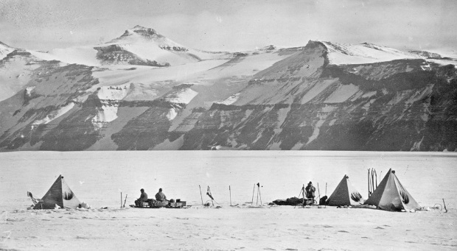
National Curriculum
As Historians we will be studying Captain Scott of the Antarctic. We will learn to sequence and look at causes of events. We will be discussing:
Why do you think Captain Scott is still famous today?
How did Scott get to the South Pole and what happened?
Why did Scott risk his life going to the South Pole?
How would Scott have felt when he arrived at the South Pole?
Why did Scott fail to get there first?
How should we remember Scott today?

As Geographers we will learn about the regions of the cold world and why the poles are so cold.

In Design and Technology we will be designing, making, testing and evaluating a model Inuit boat. As part of this we will be Investigating types of Inuit boats and their uses, exploring materials and parts of boats, designing and making a personal Inuit boat as well as testing and evaluating the boat and making judgements on the product.
As Artists we will be studying Picasso and creating Antarctic animal artwork in his style. We will learn to: draw, paint, share and develop ideas, experience and imagination; evaluate and analyse create works using the language of art. We will know about a great artist.
In Computing, we will be learning about algorithms, logical reasoning, and decomposing problems into smaller parts. Y1 will be presenters and collectors. Y2 will be photographers and researchers.

Polar Explorer
Cycle B
Year 1 and 2- Spring term
Curriculum Drivers
This term we will be following the exciting adventures of Captain Scott of the Antarctic, through his heroism and sacrifice as well as noble defeat. Join us on this frosty journey to find out why he is such an important historical figure in history!

